./

GENESIS

**Learning Report on**

**MODEL BASED SYSTEM ENGINEERING**

**(MBSE)**

(MBSE)



|  |  |  |  |  |  |
| --- | --- | --- | --- | --- | --- |
| **Ver. Rel. No.** | **Release Date** | **Prepared. By** | **Reviewed By** | **To be Approved** | **Remarks/Revision Details** |
|  | 20-12-2020 | Aiswarya Sasikumar |  |  |  |
|  |  |  |  |  |  |
|  |  |  |  |  |  |
|  |  |  |  |  |  |
|  |  |  |  |  |  |

**Details**

TABLE OF CONTENTS

ACTIVITY 1: DEEP UNDERSTANDING OF SUBSYSTEMS OF AUTOMOBILES………….………5

* 1. powertrain.5

1.2 BODY AND CHASSIS6

1.3 COMFORT FEATURES7

1.4 BODY AND CHASSIS8

1.5 BODY AND CHASSIS9

ACTIVITY 2: ECU COMPONENTS9

2.1 ECU APPLICATION NOTES9

2.2 SENSORS AND ACTUATORS9

2.2.1 SENSORS….10

2.2.2 ACTUATORS…11

2.3 SENSORS AND ACTUATORS- COMPARISON12

2.3.1 SENSORS COMPARISON – SPEED SENSOR12

2.3.2 ACTUATOR COMPARISON - INJECTORS13

ACTIVITY 3: REINVENTING AUTOMOTIVE SOFTWARE WITH MODEL BASED DESIGN14

ACTIVITY 4: ALGORITHM DEVELOPMENT USING SENSOR DATA FROM ANDROSENSOR APPLICATIOn…16

ACTIVITY 5: autoscripting…………………………………………………………………………………………………………………17

ACTIVITY 6: mbd – bcm external lighting18

ACTIVITY 7: certificateS21

**LIST OF TABLES**

**LIST OF TABLES**

Table 1: Comparison of speed sensors 13

Table 2: Comparison of Injector Actuators 13

Table 3: Requirements Table 18

Table 4: Test Plan 19

**LIST OF FIGURES**

Figure 1: Structure of a typical automobile 5

Figure 2: Lateral Bending 6

Figure 3: Longitudinal Torsion 7

Figure 4: Auto-adjusting Feature of steering 8

Figure 5: Plots of the Integrated Algorithm using Androsensor Data set 16

Figure 6: Celsius to Fahrenheit Using Auto Build 17

Figure 7: Model with Requirements 18

Figure 8: Internal structure of subsystem 18

# ACTIVITY 1

**DEEP UNDERSTANDING OF SUBSYSTEMS OF AUTOMOBILES**

### 1.1 POWERTRAIN

In a motor vehicle, the powertrain consists of the source of propulsion (e.g. the engine or electric motor) and the drivetrain system which transfers this energy into forward movement of the vehicle. The powertrain consists of the power source (e.g. the engine) and all of the components that convert the engine's power into movement of the vehicle (e.g. the transmission, driveshafts, differential and axles) whereas the drivetrain does not include the power source and consists of the transmission, driveshafts, differential and axles .A powertrain’s exact design depends on a number of factors, ranging from the type of engine (combustion, electric or hybrid) to its layout on the chassis, and this is what ultimately determines how energy efficient, dynamic and powerful the vehicle is.

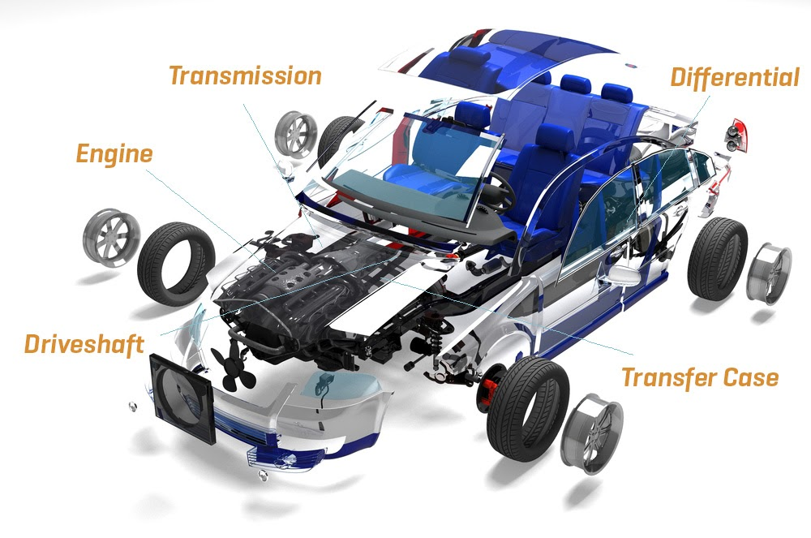

Figure 1: Structure of a typical automobile

From the initial spark of the ignition to the wheels spinning on their axes, a powertrain's influence can be felt from the front of the vehicle to the back. Put simply, a powertrain is a producer, converter and consumer of energy, all with the aim of getting the vehicle to move. A drive train consists of the following components, which together set the vehicle in motion:

* Engine
* Clutch
* Transmission
* Driveshaft
* Axle Differential

#### Working

The first step in the powertrain cycle is to switch the engine on to generate energy. This energy then has to be transferred to the wheels, which is where the transmission (consisting of the gearbox and clutch), flywheel and driveshaft come in. Referred to collectively as the ‘drivetrain’, these are the parts that take the energy, slow it down using gear ratios and transmit it as torque—or rotational force—which sets the wheels in motion. The amount of torque produced and the efficiency of the process depend on the vehicle’s transmission type: manual, which requires the driver to manually select the gears; automatic, which automates the gear selection process; semi-automatic, which does away with a clutch but keeps the manual gears; dual-clutch, which is designed for rapid gear shifting; and continuously variable, which provides an optimum gear ratio.

#### Front-wheel, rear-wheel, four-wheel and beyond

A powertrain can vary significantly depending on whether it is installed in a front-, rear- or four-wheel-drive vehicle. In a front-wheel-drive vehicle, the powertrain converts energy for the front wheels only, while for rear-wheel drive it is the back wheels that are driven by the engine. These two layouts minimize the level of mechanical complexity involved and allows the transmission to be installed in the best location for balanced weight distribution. For four-wheel drive, the powertrain is able to provide torque to all four of the vehicle’s wheels, which offers exceptional control when driving off road, over non-stable surfaces and on steep slopes. Of course, powertrains are not configured for four wheels only. There are also six-, eight- and H-drive variants, which are generally used to power heavy-duty off-road vehicles. In this case, huge amounts of power have to be produced and converted by the powertrain.

Link: <https://www.mes-insights.com/back-to-basics-whats-a-powertrain-a-893738/>

<https://www.youtube.com/watch?v=T6xrJv9SRLI>

### 1.2 BODY AND CHASSIS

Car Body or the Chassis is the basic framework of the Automobile.

* Depending upon use case, some of the common Car Body designs are Hatchback, Sedan, SUV (Sports Utility Vehicle), etc.
* Sedan designs are primarily targeted on comfort and smooth driving experience. So, they have low ground clearance and are lengthy.
* SUVs designed for rough road scenarios and have higher ground clearance.
* Hatchback designs are generally smaller than Sedans w.r.t length. And also have a good ground clearance.

The chassis generally experiences some heavy loading situations and can have an impact on people inside the Car. Torsion bars and coil springs are used to reduce the impact. Controlling this impact is also known as Suspension Systems.

Technically, design of chassis is considered based on four major loading situation

1. Vertical Bending
2. Longitudinal Torsion
3. Lateral Bending
4. Horizontal Bending

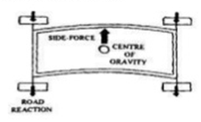

Figure 2: Lateral Bending

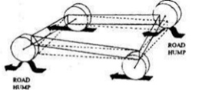

Figure 3: Longitudinal Torsion

Link: <https://axleaddict.com/cars/automotive-chassis-system#:~:text=The%20term%20%22chassis%22%20is%20used,from%2C%20a%20structurally%20independent%20frame>.

https://www.slideshare.net/RhlPtl1/automobile-chassis-and-body

### 1.3 COMFORT FEATURES

### 1. Lumbar support

Lumbar support in cars is a way to aid both drivers and passengers while sitting in car seats. They are meant to correct poor posture which has resulted in doctors treating an alarming number of patients with lower back pain. Instead of having slumped posture, drivers and passengers can now use lumbar support to sit up straight and gain many health benefits from proper posture.

**2. Power seat**

A power seat in an [automobile](https://en.wikipedia.org/wiki/Automobile) is a front [seat](https://en.wikipedia.org/wiki/Car_seat) which can be adjusted by using a [switch](https://en.wikipedia.org/wiki/Switch) or [joystick](https://en.wikipedia.org/wiki/Joystick) and a set of small [electric motors](https://en.wikipedia.org/wiki/Electric_motor). Most cars with this feature have controls for the driver's seat only, though almost all luxury cars also have power controls for the front passenger seat. In addition to fore and aft adjustments, power seats can be raised or lowered and tilted to suit the comfort of the driver and/or passenger. Many power seats allow occupants to adjust the seat lumbar or seat back, recline, all at the push of a button or flick of a switch. Cars which do not have this feature have a [lever](https://en.wikipedia.org/wiki/Lever) or bar to provide fore and [aft](https://en.wikipedia.org/wiki/Aft) adjustments.

**Power Seats and Lumbar Controls:** <https://www.youtube.com/watch?v=7Tt7Tdwiz5M>

#### **3. Adjustable Steering column**

* Tilt mechanism offers the driver to adjust the steering wheel in 7 positions.
* There are grooves in the Column and a **Spring Adjusted Lock Pin** is there. The driver just has to release the pin and adjust it according to his needs.
* The Next advancement in Adjustable Steering Column is **Tilt and Telescopic Steering Column**, which offers the driver to tilt the steering wheel as well as retract and extend it according to needs.

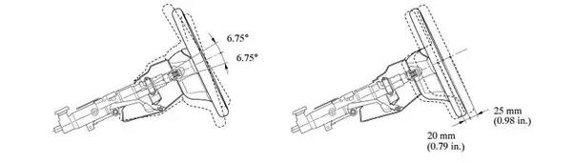

Figure 4: Auto-adjusting Feature of steering

### 1.4 SAFETY -SUBSYSTEM

**1. Active safety**: to avoid Accidents, avoiding crashes & accidents by warning to driver with additional assistance.

* Anti-Lock Braking System(ABS)
* Electronic Stability Control(ESC)
* Tire Pressure Monitoring System(TPMS)
* Lane Departure Warning System(LDWS)
* Adaptive Cruise Control(ACC)
* Driver Monitoring System(DMS)
* Blind Spot Detection(BSD)
* Night Vision System(NVS)
* Head-Up Display(HUD)

**2. Passive:** Protects from injury.

* Airbags
* Seatbelts
* Pedestrian safety System
* Occupant Sensing etc

<https://youtu.be/PNTt7lhvheE>

### 1.5 INFOTAINMENT

1. Integrated Head-Unit – It is a touch screen based device mounted on the vehicles dashboard. It act as a control center for the infotainment system.
2. Heads-Up Display- It displays the vehicles real time information like speed, navigation maps, electronic digital cluster, climate etc., on the transparent screen.
3. High-end DSPs and GPUs to support multiple displays.
4. Operating systems
5. Connectivity modules- GPS, Wi-Fi and Bluetooth
6. Digital instrumental cluster- It includes digital displays of the traditional analog gauges in the vehicles like speedometer, RPM, odometer etc.,
7. Analog and digital tuners for multi-standard radio reception
8. Multimedia support-It helps to transfer audio and video content to display screens, speakers and headphones via Bluetooth, HDMI cable and USB.
9. Advanced vehicular functions-It have features like parking assistance, daytime running parking assistance, voice assistants, light indicator.

You tube -  [*https://youtu.be/oBnkPonWv-Q*](https://youtu.be/oBnkPonWv-Q)

# ACTIVITY 2

## **2.1 ECU APPLICATION NOTES**

Mass Air flow: [*https://www.digikey.com/Site/Global/Layouts/DownloadPdf.ashx?pdfUrl=2D2099DBEE204A1BA04151D81707AD95*](https://www.digikey.com/Site/Global/Layouts/DownloadPdf.ashx?pdfUrl=2D2099DBEE204A1BA04151D81707AD95)

Automotive application notes:

*https://www.infineon.com/dgdl/Infineon-Automotive-Application-Guide-2018-ApplicationBrochure-v01_00-EN.pdf?fileId=5546d462584d1d4a015891808e617573*

## **2.2 SENSORS AND ACTUATORS**

### 2.2.1 SENSORS

* **Mass airflow sensor:**

A mass flow sensor is a sensor used to determine the mass flow rate of air entering a fuel-injected internal combustion engine. The air mass information is necessary for the engine control unit to balance and deliver the correct fuel mass to the engine.

* MAF has two sensing wires.
* One is heated by an electrical current, the other is not.

**Working Principle:**

* As air flows across the heated wire, it cools down. When the temperature difference between the two sensing wires changes, the MAF sensor automatically increases or decreases the current to the heated wire to compensate.
* **Knock Sensor:**

“Knocking” occurs when the air-fuel mixture self-ignites prematurely. Sustained knocking causes damage primarily to the cylinder head gasket and cylinder head. The knock sensor identifies the high-frequency engine vibrations characteristic of knocking and transmits a signal to the ECU. The aim is to obtain the maximum energy yield by starting ignition as early as possible. Engines with a knock sensor can reduce fuel consumption and increase torque.

**Working Principle:**

The knock sensor is located on the outside of the engine block. It is intended to record knocking noise in all engine operating states in order to prevent engine damage. The knock sensor "listens out for" the structure-borne vibrations from the engine block and converts these into electrical voltage signals.

* **Coolant Sensor:**
* found somewhere near the engine thermostat, which allows it to function optimally.
* tip of the CTS is located right next to the engine coolant

**Working Principle:**

The sensor works by measuring the temperature that’s being given off by the thermostat and/or the coolant itself. The temperature is then sent to the on-board control system. From there, vehicle’s computer will use this temperature information to either continue operating or adjust certain engine functions, always working to keep the engine temperature at an ideal level. As the control system receives the temperature from the CTS, it may trigger the cooling fan to either shut off or turn on. Additionally, it may signal the need for a richer fuel mixture or open the exhaust gas recirculation.

* **Fuel** [**Temperature Sensor**](https://www.elprocus.com/temperature-sensors-types-working-operation/)**:**
* The fuel temperature sensor determines the amount of fuel that needs to be injected, and sends this information to your car's engine control unit (ECU). A warm fuel that's less dense burns easily, so the temperature sensor signals the ECU to inject more fuel. If the fuel is cold and denser, the opposite occurs.

*https://cecas.clemson.edu/cvel/auto/sensors/temperature.html*

* **Vehicle Speed Sensor:** The speed sensor uses the variable reluctance magnetic sensing principle, whereby a cylindrical permanent magnetic core with a coil wire wound around it, mounted on the stationary hub carrier, axle casing or back plate, produces a magnetic field (flux) which overlaps the rotating exciter ring.

[*https://www.sciencedirect.com/topics/engineering/speed-sensor#:~:text=11.40*](https://www.sciencedirect.com/topics/engineering/speed-sensor#:~:text=11.40)*)%20The%20speed%20sensor%20uses,overlaps%20the%20rotating%20excitor%20ring.*

* **Throttle Position Sensor:** This sensor monitors how far down the accelerometer pedal is pushed and gives the output current determining the position of the pedal. The position of the pedal controls the airflow of the engine.

**Working Principle:**

* This sensor is a three wired [potentiometer](https://www.elprocus.com/potentiometer-construction-working-and-applications/). Through the first wire, a 5V power is supplied to the sensors resistive layer. The second wire is used as ground whereas the third wire is connected to the potentiometer wiper and provides input to the Engine control system.

[*https://www.elprocus.com/different-types-of-sensors-used-in-automobiles/*](https://www.elprocus.com/different-types-of-sensors-used-in-automobiles/)

**2.2.2 Actuators**

Actuators are a subdivision of transducers. They are devices which transform an input signal (mainly an electrical signal) into motion. This includes electrical motors, pneumatic actuators, hydraulic pistons, relays, piezoelectric actuators, thermal bimorphs, and electro active polymers.

These are some of the common actuators used in vehicles:

#### **Injectors**

Injector is an injection nozzle with solenoid that is controlled by ECM. Using intake air quantity and engine rpm, ECM calculates basic fuel injection time, and calculates corrective fuel injection period time on the basis of engine coolant temp, feedback signal from oxygen sensor during close-loop-control.

#### **Spark Plugs**

Spark plugs transmit electrical energy that turns fuel into working energy. A sufficient amount of voltage must be supplied by the ignition system to cause it to spark across the gap of the spark plug. This is called Electrical Performance.

#### **Ignition Coils**

The Ignition coil functions as an energy-storage device and transformer. It is supplied with DC voltage from the alternator, and provides the high tension ignition pulses for the spark plugs. The MFI engine adopts a computerized ignition system. The ECM calculates ignition timing, timing advance, and knocking control by the sensor signals.

#### **Fuel Pump**

Fuel Pump is powered from the Vehicle battery and connected to the engine ECU , to give the engine the fuel at the right pressure suitable for its work

#### **Idle Speed Actuator**

ISA (Idle Speed Actuator) is installed at throttle body of engine and control air intake rate into engine depending on ECU signal in order to control idle rpm, Idling speed is controlled relying on a number of parameters including actual engine rpm, coolant temperature, air-conditioning system and headlamp operation status, etc.

#### **Cooling Fan Control**

In order to maximize cooling efficiency and minimize cooling fan motor drive current, radiator fan and condenser fan speeds are controlled using three speed modes such as low, medium, and high speed, on the basis of coolant temperature, car speed, air conditioning switch signal, and conditioning compressor operation signal.

#### **A/C compressor control**

A/C Compressor Control Outline A/C Compressor Control is used when accelerating or engine load is instantly increased greatly, in order to improve engine acceleration by temporarily turning off A/C compressor.

## **2.3 SENSOR ACTUATOR COMPARISON**

**2.3.1 SENSOR COMPARISON - SPEED SENSOR**

|  |  |  |
| --- | --- | --- |
| Description | TLE4986C-XAS-M47 -Infineon | TLE4983C-HTN E6747 -Infineon |
| Feature | Hall switching sensor to measure speed or phase of pole/tooth wheels | TPO True Power On functionality |
| Range | Range not mentioned | Increased BTPO range |
| Type | Mono-cell chopped Hall system | Mono-cell chopped Hall system |
| Mounting | TIM Twisted Independent Mounting | TIM Twisted Independent Mounting |
| Algorithm | Dynamic self-calibrating algorithm | Dynamic self-calibrating algorithm |
| Switching points | End-of-line programmable switching points | End-of-line programmable switching points |
| Stress Management | High resistance to mechanical stress | High resistance to mechanical stress |
| Output | Digital output signal (voltage interface) | Digital output signal (voltage interface) |
| Package | Module package PG-SSO-3-52 | Package: PG-SSO-3-91 with nickel plating |
| Others | Enhanced immunity against ESD and EMC   Improved µ-cut capability  Enhanced operating temperature range | Short-circuit protection Module style package with two 4.7/47 nF integrated capacitors |

Table 1: Comparison of speed sensors

[*https://www.infineon.com/dgdl/Infineon-TLE4986C-XAS-M47-DS-v01_10-EN.pdf?fileId=5546d4625d5945ed015dadb1296e242a*](https://www.infineon.com/dgdl/Infineon-TLE4986C-XAS-M47-DS-v01_10-EN.pdf?fileId=5546d4625d5945ed015dadb1296e242a)

[*https://www.infineon.com/dgdl/Infineon-TLE4983_HTNE6747-DS-v01_01-en.pdf?fileId=db3a30434039e4f7014053624f654af9*](https://www.infineon.com/dgdl/Infineon-TLE4983_HTNE6747-DS-v01_01-en.pdf?fileId=db3a30434039e4f7014053624f654af9)

# 2.3.2 ACTUATOR COMPARISON - INJECTORS

|  |  |
| --- | --- |
| Air Injectors | Solid Injectors |
| Fuel is supplied with high pressure air into the combustion chamber | Fuel is supplied at a very high pressure from the fuel pump to the fuel injector, from where it is injected to the combustion chamber |
| Pressure of the air is about 70 bar | Fuel is supplied at a pressure of about 200 bar |
| A Multistage air compressor is required to supply blast of high pressure air | Fuel is directly injected into cylinder without compressed air |
| Air compressor needs extra maintenance | Maintenance cost is less here |
| Overall Efficiency is less as considerable amount of power is used to run compressor | Efficiency is better here. |

Table 2: Comparison of Injector Actuators

[*https://www.youtube.com/watch?v=KTp2lstOAd0*](https://www.youtube.com/watch?v=KTp2lstOAd0)

**ACTIVITY 3**

**REINVENTING AUTOMOTIVE SOFTWARE WITH MODEL-BASED DESIGN**

As the complexity of embedded systems increases, automotive software engineers face pressure to pursue competing goals:

* Make the automotive technology components more customizable
* Comply with safety standards and regulations
* Lower development costs
* Accelerate time to market

Model-based design is one solution that substitutes the traditional approach to automotive software development.

**Model-Based Design versus Tradition**

The difference between model-based design and traditional design methodology is dramatic.

Traditional design is software-centric. It treats software as the main entity in each of the following phases:

1. ECU designs leverage block diagrams or computer modeling techniques
2. Designs are implemented in a programming language
3. ECUs are integrated with a plant model
4. Simulation is used to adjust controller parameters
5. Testing and reiteration

In the model-based design methodology, computer-modeling techniques are used throughout the design process while the code is generated automatically. Here are the stages of this process:

1. The development team creates a conceptual design.
2. A mathematical model is created from a specification using graphical design and simulation tools like [Matlab](https://www.mathworks.com/products/matlab.html), [Simulink](https://www.mathworks.com/products/simulink.html), and [Stateflow](https://www.mathworks.com/products/stateflow.html).
3. The model captures all the information about how the embedded system should run in a real vehicle (the component and its vehicle are modeled as one dynamic system).
4. The mathematical model is used in all development stages including design, implementation, and validation.
5. The code is automatically generated based on the perfected model and incorporated into an embedded microprocessor.

This way, the model-based design prioritizes the functionality of a component and assesses its integration into a larger system during each stage of development, well before the physical prototype is created.

**The Benefits of Model-Based Design in Automotive**

The model-based design paradigm grants significant benefits to automotive developers that traditional software development can’t:

* **Increased productivity:** All phases are based on the same mathematical model. Several models may be used for simulation without increasing development time or cost.
* **Decreased development time and cost:** Model-based design speeds up the overall development process. With testing at each stage, development teams can avoid costly changes in later stages.
* **Ability to introduce major changes late in the development process:** Block-oriented workflow and automatic code generation allow automotive engineers to correct erroneous specifications and replace large functional blocks.
* **Consistent documentation and implementation:** Since the model description is also the basis for actual code, documentation and implementation are kept consistent.
* **Higher reliability:** Extensive simulation, early testing, and automatic code generation eliminate the possibility of code errors and reduce the need for in-system debugging.
* **Technology reuse:** Simulation blocks and vehicle tests can be saved in a library and reused in the process of developing other models.

Model-based design allows faster releases, enhanced design, and better reliability in automotive embedded systems. Tools for software modeling and simulation can improve automotive systems as long as they continue to demonstrate benefits and become more common in the industry.

**ACTIVITY 4**

**ALGORITHM DEVELOPMENT USING SENSOR DATA FROM ANDROSENSOR APPLICATION**

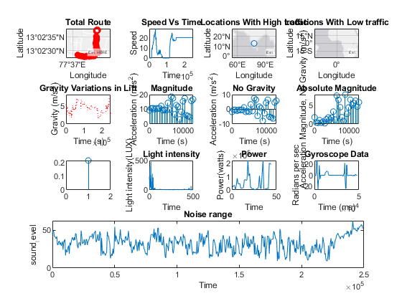

Figure 5: Plots of the Integrated Algorithm using Androsensor Data set

**Link to Matlab Code:**

**Link to pdf:**

**Link to html file:**

**ACTIVITY 5**

**AUTOSCRIPTING**

**5.1 Auto build, Auto Fetch and Replace:**

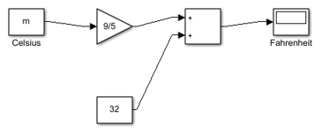

Figure 6: Celsius to Fahrenheit Using Auto Build

*:*

**Link to Matlab Code:**

**Link to pdf:**

**Link to html file:**

**5.2 Auto Find:**

**Link to Matlab Code:**

**Link to pdf:**

**Link to html file:**

**File for Autofind (C_to_F):**

**ACTIVITY 6**

**MBD – BCM External Lighting**

**RESEARCH:**

**YOUTUBE LINK -** <https://www.youtube.com/watch?v=glObZE-XS3Q>

**REQUIREMENTS:**

|  |  |  |
| --- | --- | --- |
| **INDEX** | **FEATURES** | **MODES** |
| **1.** | **POWER** | **ON**  **OFF** |
| **2.** | **HEAD LIGHTS** | **DEFAULT**  **LOW BEAM**  **HIGH BEAM** |
| **3.** | **INDICATOR LIGHTS** | **OFF**  **LEFT**  **RIGHT** |
| **4.** | **HAZARD LIGHTS** | **LEFT AND RIGHT** |
| **5.** | **BRAKE LIGHTS** | **OFF**  **ON** |

Table 3: Requirements Table

**TEST PLAN:**

|  |  |  |  |  |
| --- | --- | --- | --- | --- |
|  | **MODE** | **INPUT** | **EXPECTED OUTPUT** | **ACTUAL OUTPUT** |
| **POWER** | **OFF** | **0** |  |  |
| **HEADLIGHTS** | **DEFAULT** | **1** | **0** |  |
|  | **LOW BEAM** | **2** | **0** |  |
|  | **HIGH BEAM** | **3** | **0** |  |
| **INDICATOR LIGHTS** | **OFF** | **1** | **0** |  |
|  | **LEFT** | **2** | **0** |  |
|  | **RIGHT** | **3** | **0** |  |
| **HAZARD LIGHTS** | **LEFT AND RIGHT** | **5** | **0** |  |
| **BRAKE LIGHTS** | **OFF** | **1** | **0** |  |
|  | **ON** | **2** | **0** |  |
| **POWER** | **ON** | **1** |  |  |
| **HEAD LIGHTS** | **DEFAULT** | **1** | **11** |  |
|  | **LOW BEAM** | **2** | **22** |  |
|  | **HIGH BEAM** | **3** | **33** |  |
| **INDICATOR LIGHTS** | **OFF** | **1** | **11** |  |
|  | **LEFT** | **2** | **22** |  |
|  | **RIGHT** | **3** | **33** |  |
| **HAZARD LIGHTS** | **LEFT AND RIGHT** | **5** | **55** |  |
| **BRAKE LIGHTS** | **OFF** | **1** | **11** |  |
|  | **ON** | **2** | **22** |  |

Table 4: Test Plan

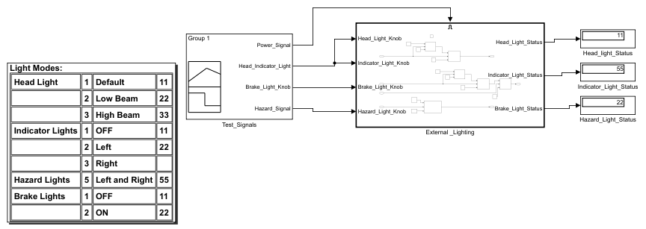

Figure 7: Model with Requirements

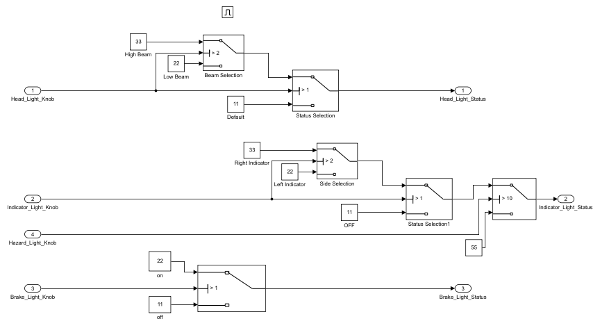

Figure 8: Internal structure of subsystem

**Link to html:**

**Link to pdf:**

**6. CERTIFICATES**

**MATLAB ONRAMP CERTIFICATE:**

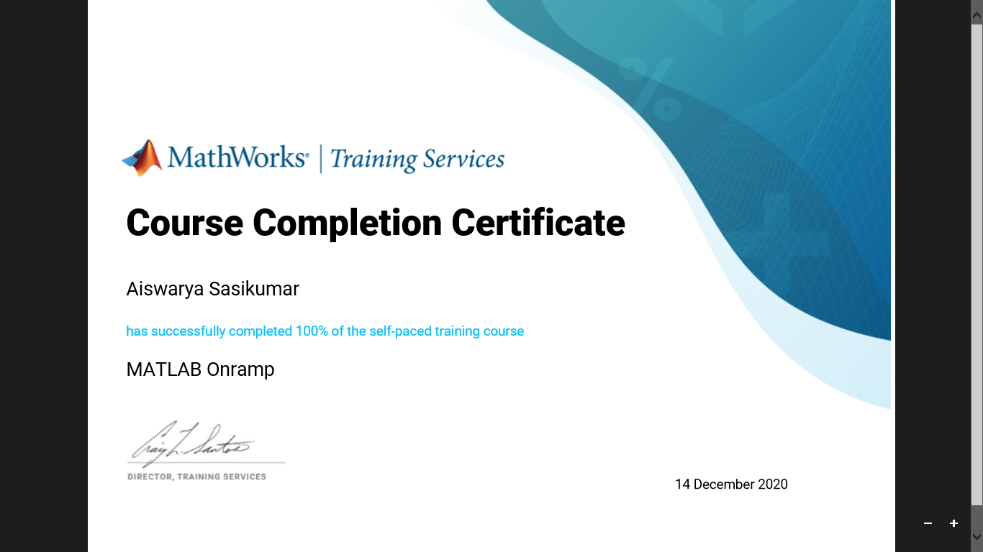

**MATLAB ONRAMP PROGRESS REPORT:**

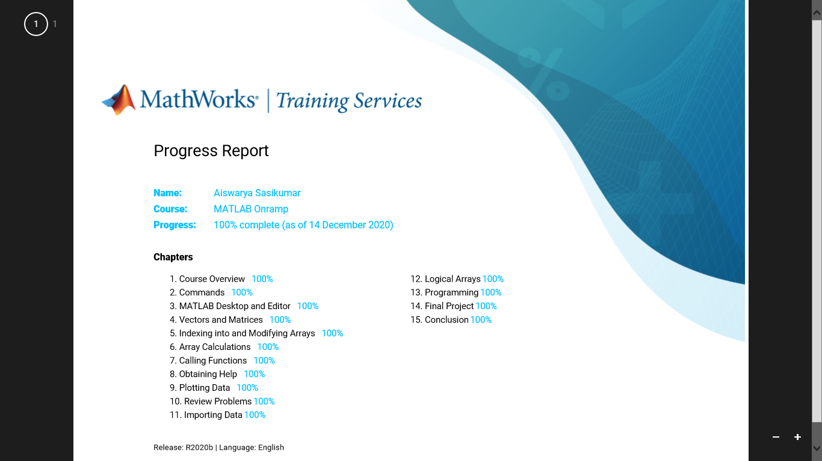

**SIMULINK ONRAMP CERTIFICATE:**

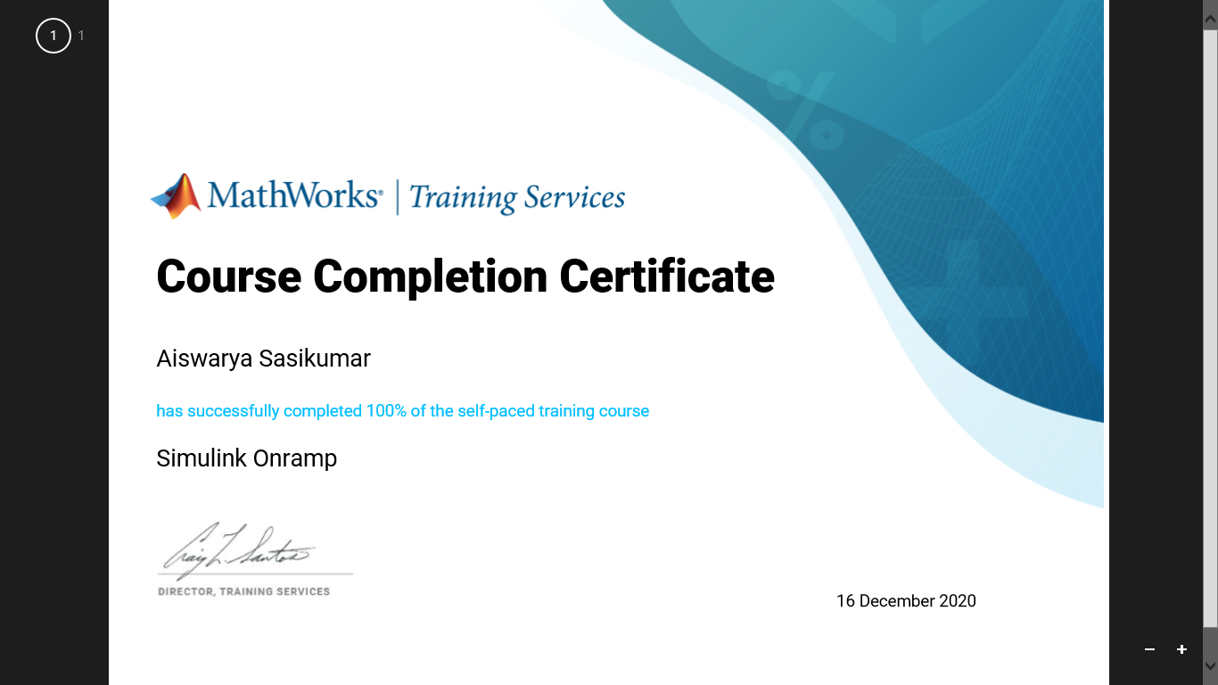

**SIMULINK ONRAMP PROGRESS REPORT:**

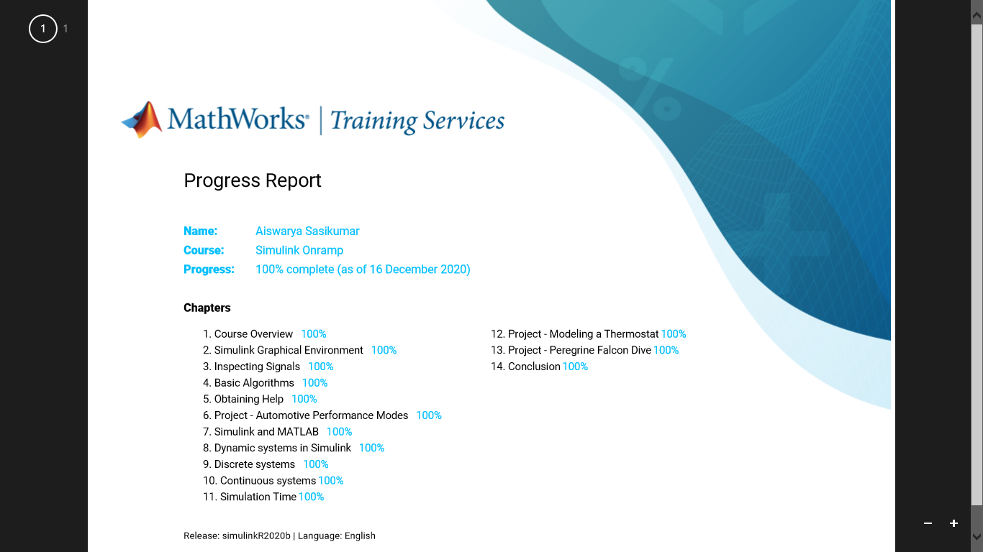

**STATEFLOW ONRAMP CERTIFICATE:**

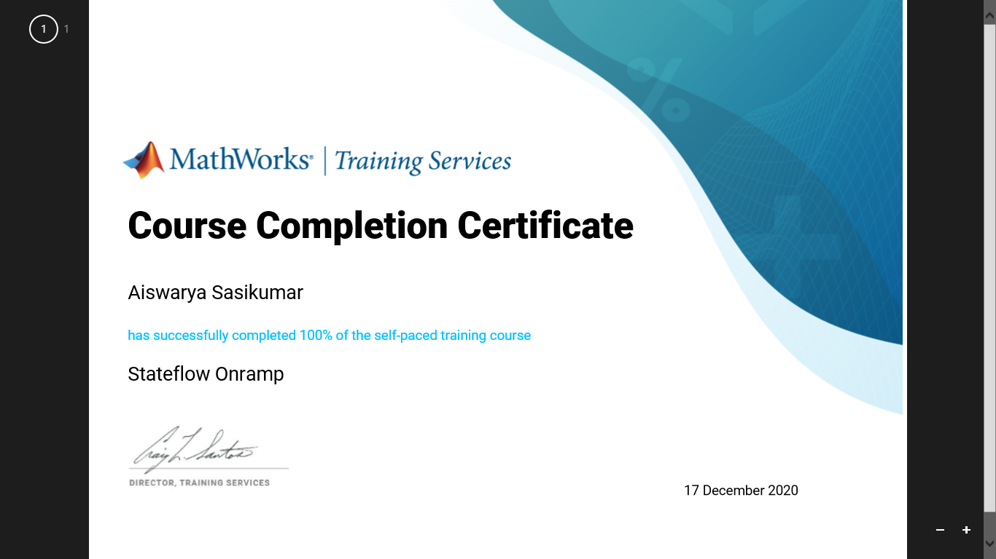

**STATEFLOW ONRAMP PROGRESS REPORT:**

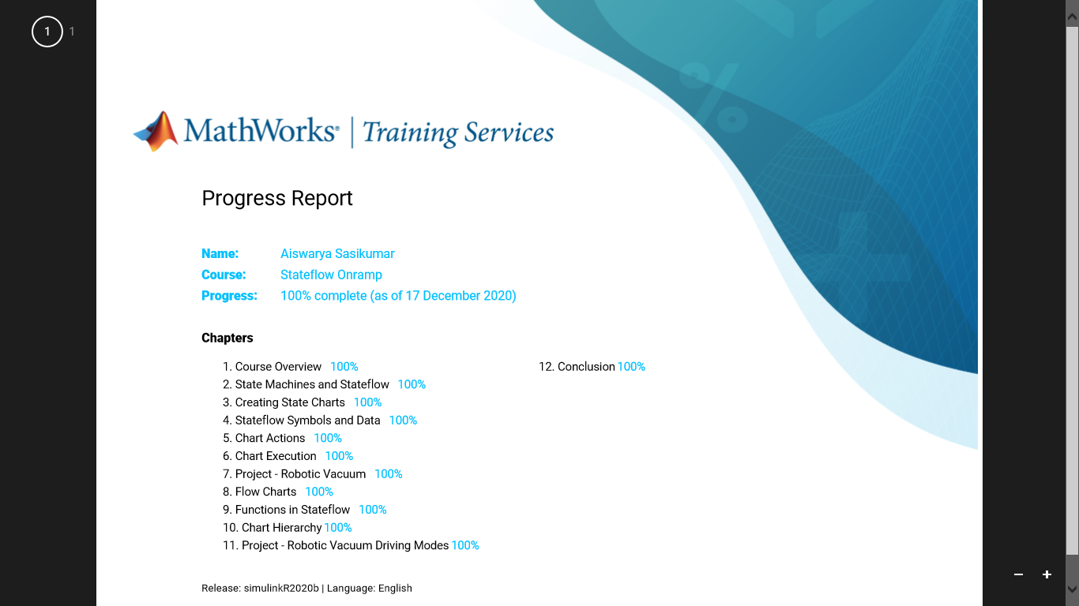

**MBSE COURSE CERIFICATE:**

